MALLORY RIDGE / GARDOM LAKE UPLANDS UNDER THREAT January 2020
In early 2020 a small number of residents received postcards from Tolko asking for feedback about 4 proposed cut blocks in the watersheds to the south of Gardom Lake, specifically, above the lake south to the Grange Road bowl and Glenmary Road. The cut blocks are within the last remaining forested Crown Land between Mallory Ridge and Glenmary Road, on the Enderby side. The majority of residents were not aware of the logging proposals until March 13th, with the deadline for submissions only 4 days away. Once alerted, local residents quickly responded with feedback expressing concerns about the possible adverse effects of logging on the lake and damage to the beautiful upland area locally referred to as Mallory Ridge. The ridge includes the scenic bluffs overlooking Gardom Lake. This area was considered for a Conservation Park by the CSRD in 2008. Unfortunately, the area was not protected at that time and it is no longer being considered for park status by the CSRD.
In the Electoral Area D Parks Plan (Oct. 15, 2008), the CSRD defined Conservation Park as “a large natural area that provides for low-impact outdoor recreation opportunities such as nature appreciation and wilderness hiking. Focus is more on conservation and protection of natural values of the area.” In the same document it further states that “Mallory Ridge is an upland area with high conservation values located to the southeast of Gardom Lake. It averages about 700 m ASL [above sea level] and reaches about 750m at its highest point. The area is particularly rich in tree and plant species because the dry southern interior bioregion meets the wetter interior bioregion and this transition encourages a great variety of vegetation to flourish. The area also includes a variety of rich habitats which allow many species of birds to successfully nest and raise their young. Mallory Ridge provides year round opportunities for hiking, mountain biking, horseback riding, and cross country skiing or snow shoeing.”
Of the many concerns expressed by residents, watershed impacts are at the top of the list. The BC Lake Stewardship and Monitoring Program Gardom Lake 2010-2012 report defines watershed as “the entire area of land that moves the water it receives to a common waterbody. The term watershed is misused when describing only the land immediately around a waterbody or the waterbody itself. The true definition represents a much larger area than most people normally consider. The watershed area of Gardom Lake is 4.17 sq km (approx. 1030 acres)”. “Every component of a watershed …has an important function in maintaining good water quality and a healthy aquatic environment. It is a common misconception that the detrimental land use practices will not impact water quality if they are kept away from the area immediately surrounding a water body. Poor land use practices anywhere in a watershed can eventually impact the water quality of the downstream environment.”
There are three watersheds that would be affected by the proposed logging, the Gardom Lake watershed, the Grange Road bowl (Ferguson Creek) going into Deep Creek and the Glenmary watershed. Please refer to the following map showing the four proposed logging blocks in conjunction with property lines and some watershed boundaries.
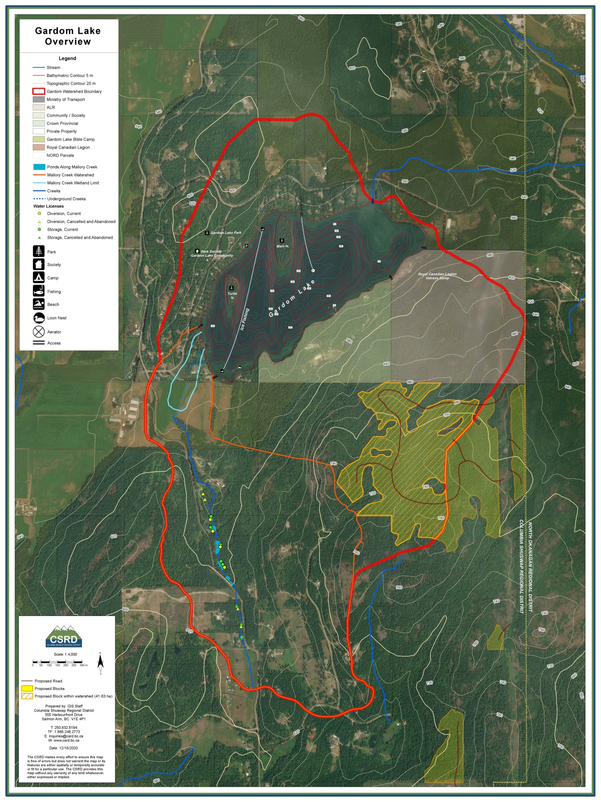
PROPOSED LOGGING. Proposed logging within the Gardom Lake watershed is light green with yellow cross hatches. Proposed logging within the Grange Road bowl and Glenmary watershed areas are light green with no crosshatching.

In all three watersheds, the loss of the tree canopy could result in a faster snow melt in the spring. Instead of slowly soaking into the ground and replenishing aquifers, water would run off quickly. Gardom Lake would experience a large influx of water over a shorter period of time in the spring, and groundwater flows into the lake from the aquifer would be reduced in the summer. This could result in higher water temperatures in the lake in the summer along with a lower water level. This in turn could have a detrimental effect on water quality, fish and other aquatic organisms, plants and birds. All three watersheds have an intricate system of small ponds, marshes, seeps, and watercourses, many of them seasonal. These could dry up sooner in the summer season.
Residential and agricultural properties on both sides of Mallory Ridge rely on groundwater, ponds or creeks, either directly or indirectly, for their domestic water supply. Some domestic wells in the area supply minimal water and some residents must haul water. Many residents and farmers are concerned logging will affect water availability, aquifer replenishment, and disrupt the natural underground springs and small streams.
Logging results in soil disturbance, especially if stumps are uprooted and turned. Siltation and hillside instability are concerns.
There are multiple unique and fragile habitats on Mallory Ridge. It is a wildlife refuge and safe corridor for many birds and animals. Large mammals seen this year include elk, deer, moose, black and grizzly bear and cougar. All wildlife deserves protection from shrinking habitat.
The remaining Crown Land along Mallory Ridge is well used for non-motorized activities in all four seasons including hiking, walking, mountain biking, snowshoeing, skiing, orienteering, bird watching, nature appreciation and horseback riding. Users find peace and solitude while enjoying the many trails and outstanding views overlooking the valley from the cliffs.
The 20+ kms of social trails are well used and maintained by locals. Some of them are old skid trails from the 1940’s when logging was done selectively and did not leave the ecosystem unrecognizable. The longstanding social trails are well known and are a valuable community resource for minimal impact recreation, which is increasingly in demand. This is especially true because the trails are easily accessible and close to communities on both sides of Mallory Ridge. The proposed logging blocks would destroy these trails which showcase the beautiful varied ecosystems including flower meadows, ponds and hidden water features. Locals and visitors to the area all express how important it is to save this Crown Land from logging.
A group of concerned residents has formed an advocacy group and initial contact has occurred with Tolko. It is unclear when or if the proposed logging would take place. Tolko has promised to meet with local residents but COVID regulations currently prevent this.
Our advocacy group has been very proactive and appreciates all the support we have received. If you are interested in being notified of future meetings with Tolko, or can offer expertise or assistance, please send an email to toelmarshall@gmail.com. The Gardom Lake Stewardship Society is critical to the support and success of our advocacy and we encourage everyone to consider becoming a member.

